Fundamentals of Materials Science

Homework 6, SS 2017

- What type(s) of bonding would be expected for each of the following materials: solid xenon, calcium fluoride (CaF2), bronze, cadmium telluride (CdTe), rubber, and tungsten?

For solid xenon, the bonding is van der Waals since xenon is an inert gas.

For CaF2, the bonding is predominantly ionic (but with some slight covalent character) on the basis of the relative positions of Ca and F in the periodic table.

For CdTe, the bonding is predominantly covalent (with some slight ionic character) on the basis of the relative positions of Cd and Te in the periodic table.

For bronze, the bonding is metallic since it is a metal alloy (composed of copper and tin).

For rubber, the bonding is covalent with some van der Waals. (Rubber is composed primarily of carbon and hydrogen atoms.)

For tungsten, the bonding is metallic since it is a metallic element from the periodic table.

- Which of the following electron configurations is for an inert gas?

  - 1s²2s²2p⁶3s²3p⁶
  - 1s²2s²2p⁶3s²
  - 1s²2s²2p⁶3s²3p⁶4s¹

  - 1s²2s²2p⁶3s²3p⁶3d²4s²

The correct answer is A. The 1s²2s²2p⁶3s²3p⁶ electron configuration is that of an inert gas because of filled 3s and 3p subshells.

- Make a plot of bonding energy versus melting temperature for the metals listed in Table

2.3. Using this plot, approximate the bonding energy for molybdenum, which has a

melting temperature of 2617ºC.
Below is plotted the bonding energy versus melting temperature for these four metals.

From this plot, the bonding energy for molybdenum (melting temperature of 2617ºC) should be approximately 680 kJ/mol. The experimental value is 660 kJ/mol.
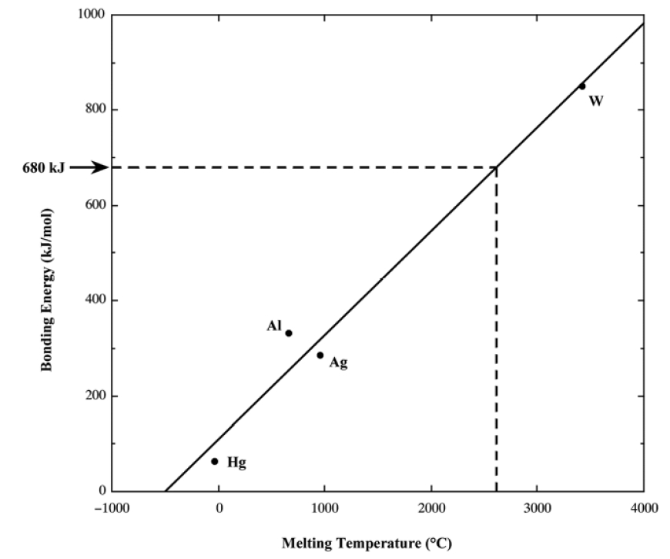

- Beryllium and magnesium, both in the 2A column of the periodic table, are lightweight metals. Which would you expect to have the higher modulus of elasticity? Explain, considering binding energy and atomic radii and using appropriate sketches of force versus interatomic spacing.

The smaller Be electrons are held closer to the core, therefore ∴ held more tightly, giving a higher binding energy:
4 Be 1s²2s² E = 29 ×10⁴ MPa rBe = 1.143 Å
12 Mg 1s²2s²2p⁶3s² E = 4×10⁴ MPa rMg = 1.604 Å

- The following questions concern two hypothetical materials, R and B, with these curves (see figure below) showing the net interatomic forces as a function of interatomic separation.

  - Which material will have a higher modulus of elasticity, and why?

  - Which material will have a higher melting point, and why?

  - Which material will have a larger coefficient of thermal expansion, and why?

Hint: You can integrate graphically.
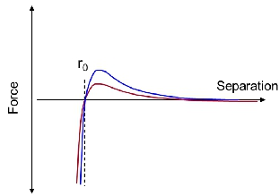

The answers are B, B, R, for the above questions, respectively.

